­­­­­

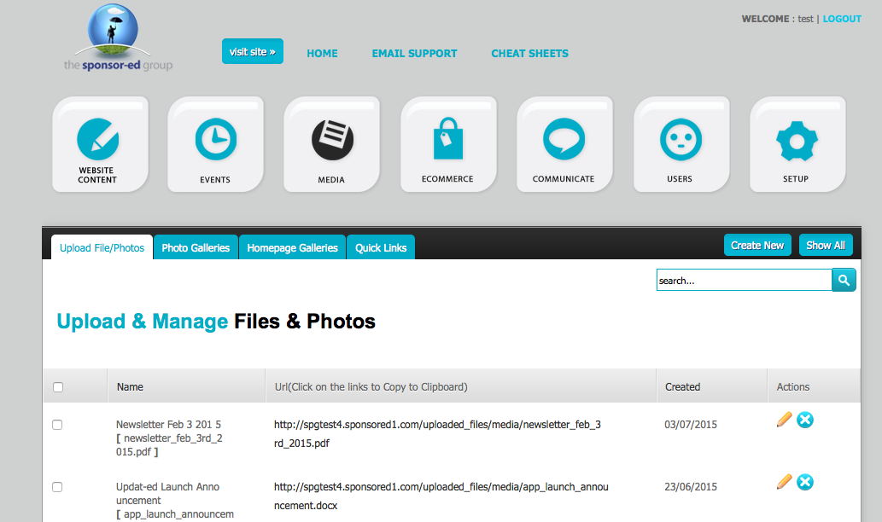

**3.** Give your media a title and click on **BROWSE.**

**4.** Browse your computer for the file that you want and click **OPEN**.

**5.** Once loaded click on **SUBMIT.**

**1.** Go to the ***MEDIA*** section of your CMS.

**2.** In ***Upload/Files & Photos*** click **Create New**.

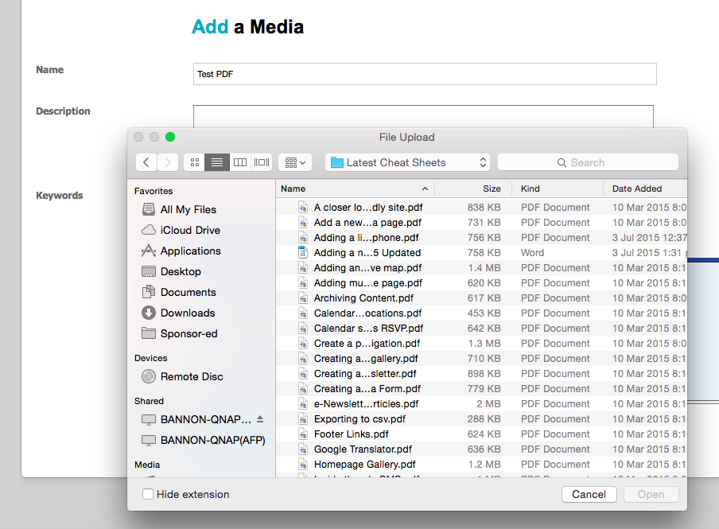

**5.** Submit your Media Page.

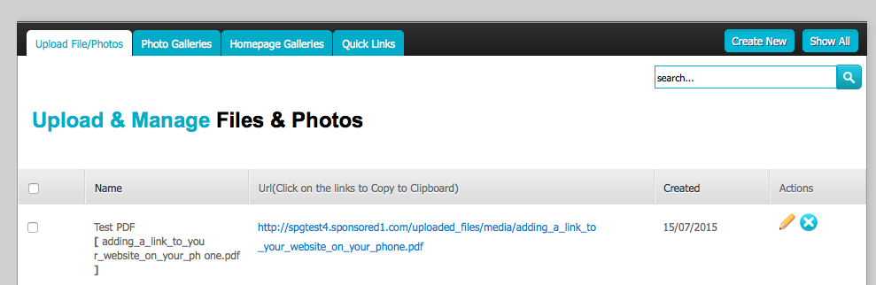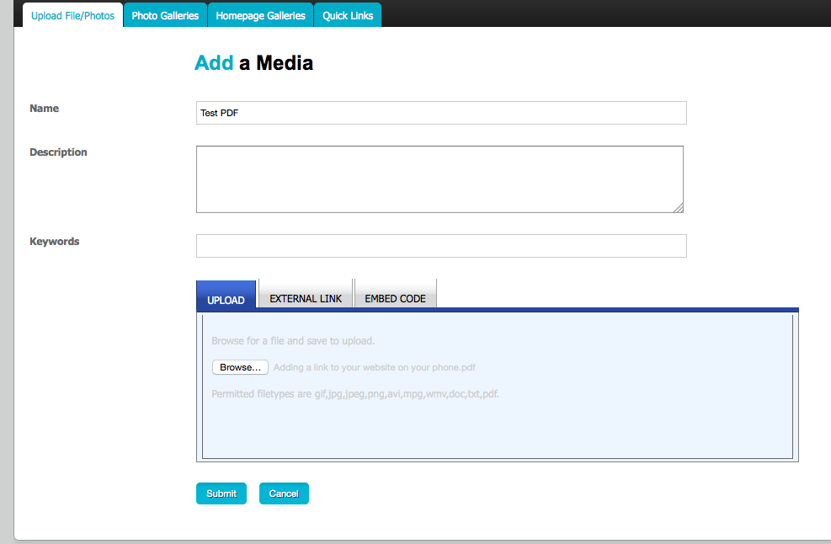

**6.** In **MEDIA**, click on URL of the file that you just uploaded.

**7.** A pop up window will open for you to COPY the URL to your clipboard. Hit **CTRL + C** on your keyboard. (This is a shortcut to COPY), then click on OK in the pop up window.

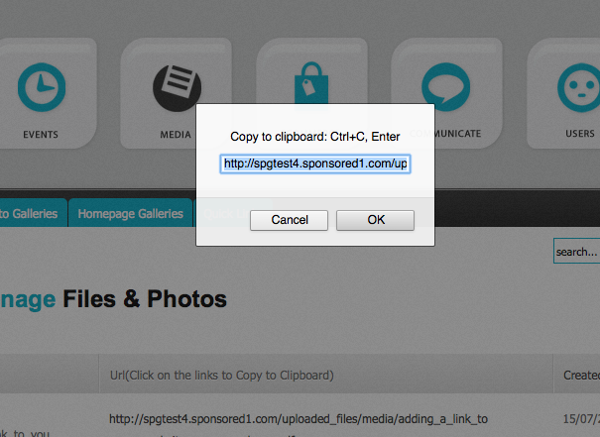

**8.** Go to **WEBSITE CONTENT** and find the page you wish this media to land. Click on the **PENCIL** icon to edit this page.

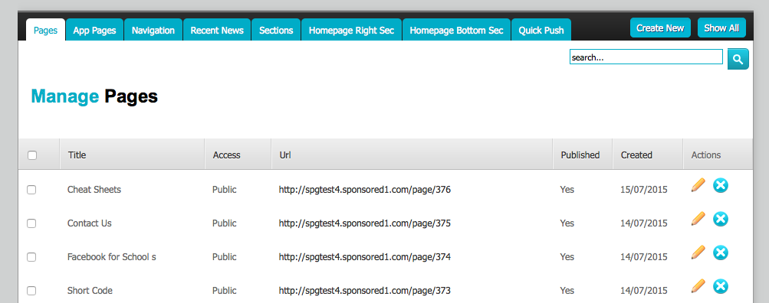

**9.** Type the name you would like to give your media and highlight it. Click on the **CHAIN** icon (insert/edit media).

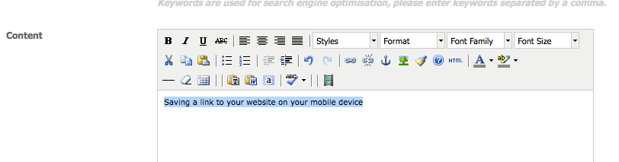

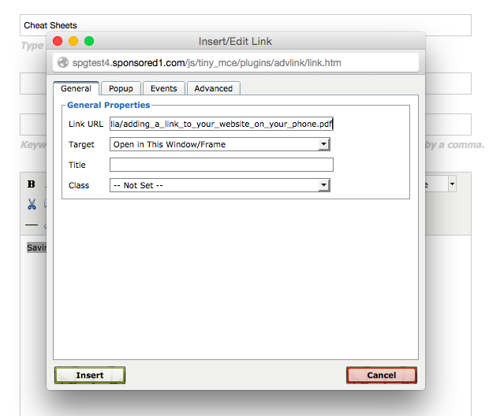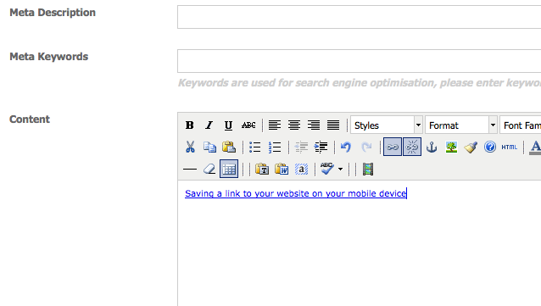

**10.** Paste the URL that was copied to your clipboard into the **LINK URL** box. Click on **INSERT.**

**12.** Visit your site to view your new link!

**11.** Your media is now linked. Click on **UPDATE** at the bottom of the page.