We’re very pleased to inform you that our school has implemented a phone app called Updat-ed that will make connecting with you so much more convenient.

To download the app just visit the App Store for iPhones or Google Play for Android’s. Search for Updat-ed and from the menu select our school. We’ll receive your registration request and will need to approve you before your app is up and running.

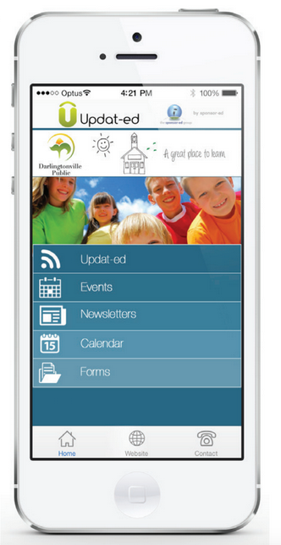
So what will the app do?

The app’s great for sending out alerts and reminders with one of its best features being the ability to save events directly into your phone’s calendar.

If you are experiencing difficulty with your app please take a look at our Trouble Shooting Guide. This guide can be found on the sponsor-ed website: www.sponsor-ed.com.au under SUPPORT. Any further queries should be directed to: helpdesk@sponsor-ed.com.au

Please state the following in your email to helpdesk:
- Your school
- Name and email address
- Model phone/tablet
- Software version
We hope you enjoy being Updat-ed.

